



[This Photo](https://maken.wikiwijs.nl/168813/Present_Simple_vs__Present_Continuous) by Unknown Author is licensed under [CC BY](https://creativecommons.org/licenses/by/3.0/)

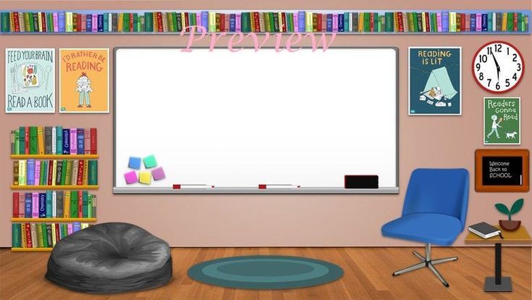

**Business Education and Computers**

**6th through 8th Grade**

**See you in class!**



Class Links

8th Grade <https://rcboe.instructure.com/courses/184060>

7th Grade<https://rcboe.instructure.com/courses/184147>

6th Grade<https://rcboe.instructure.com/courses/184152>